Prior to Arrival
  - Only members of British Water Ski & Wakeboard (Tel: 01932 579935 bwsw.org.uk) will be permitted to buy permits to ski etc on the lake, proof of membership is necessary. A BWSW member must be present in the boat at all times when skiing or wakeboarding etc.
  - Proof of power boat insurance, including minimum 3rd party indemnity of at least £3,000,000 is necessary. Any person driving the boat must be insured.
  - The registered boat owner must provide proof of completion of either the British Water Ski and Wakeboard Association’s Ski Boat Driver 1 (SBD1) course or the RYA’s Powerboat Level 2 course.
  - The boat driver must have completed either the British Water Ski and Wakeboard Association’s Ski Boat Driver 1 (SBD1) course, the RYA’s Powerboat Level 2 course or be under instruction from someone who has completed one of the above courses. When providing instruction to a driver without a qualification, the person providing instruction must be positioned next to the driver.
  - The registered owner of the boat is responsible for the actions and safety of everyone on the boat.
  - Ballast tanks and boats should be sanitised prior to arrival at the Lake to prevent invasive species spread.
  - No new registration of boats over 22ft. All new boats over 20ft - details must be sent through to us at least 5 days before arrival so details can be checked for suitability.
  - The Company and their Agents reserve the right to ban any boat or person from using the lake for power boat and water-skiing purposes and to impose any time and or zoning conditions whenever they deem necessary.
  - Any driver and observer must meet the requirements set out by your insurer.
  - Any activity undertaken must be in accordance with your insurance.
  - All engines must be properly silenced. Water scooters, Jet Skis, Jet Bikes, Hovercraft, Hydrofoils and paragliding are not acceptable and are banned on the lake together with any abnormally noisy craft. If there is any question or dispute as to what is classified as abnormally noisy or unsuitable craft or equipment, then this shall be the decision of the Company, or their Agents and their decision shall be final.

On Arrival
  - Permits to ski on the lake are obtainable at Lakeside shop.
  - Season permits will cover the period from the 14th March to the 9th November and may be used at all times in accordance with the time limits imposed.
  - There are 'no go' areas on the lake, which are marked in red and yellow on the map and by red and yellow buoys on the lake. It is necessary to be aware of these ‘no go’ areas before you launch your craft and activity restricted zoning may also apply, see below. Ballasted boats should keep 100m from the reed edge and east of the line marked B on the map
  - The lake is closed for waterskiing etc between the 9th November and the 14th March.
  - Access to the jetty areas is for launching / recovery purposes only. Cars, trailers etc must be removed to a car park at all other times.

On The Lake
  - Waterskiing etc to be confined to the period beginning one hour after sunrise and ending one hour before sunset or between 6.00am and 9.00pm. whichever is the lesser.
  - The speed limit of 8 kilometres per hour (5m.p.h.) must be observed at all times unless towing a skier, wakeboarder or inflatable or recovering a skier from the water.
  - Power boats and water skiers etc will not be allowed to take-off or land within 200 yards of the launching area and the speed limit of 8 kilometres per hour (5 m.p.h.) must be observed at all times within the launching area.
  - When leaving the launching area, all powerboats must proceed in an anticlockwise direction and keep this direction as a general rule around the lake. P-turns should not be used without agreement and understanding of other ski-boats etc. using the lake.
  - When towing a water skier or inflatable etc, each boat must have a driver and an observer both of whom must be not less than 16 years of age one being at least 18 years of age. An exception is made for observers over 14 years of age who have completed the LLWSC young observer course.
  - No more than SIX boats are to be actively engaged in towing a skier etc. at any one time. On Sundays after 5.00pm, no more than five boats are to be actively engaged in towing a skier/ wakeboarder etc. at any one time.

  - Between 6a.m. and 11 a.m. the lake will be divided into 2 zones:-
Zone A skiing, kneeboarding and Slalom use.
Zone B Wakeboarding, Wake Surfing and inflatables etc (when permitted see chart and map below).
These Zones will only be active when boats involved in more than one activity type are active. Exception for LLWSC organised courses with agreement of Lake management.
  - Skiing etc is not permitted between 11.00am and 5.00pm on Sundays and bank holiday Mondays.
  - No inflatable devices on Sundays or before 11.00am on Saturdays
  - A red flag must be flown any time there is a person/skier in the water.
  - Boats should not produce excessive wakes & must keep a safe distance from other lake users. Ballast should not be used when it will adversely affect other lake users e.g. busy periods like Saturday afternoon.
  - Ballasted tanks in boats should only be used (filled) east of the line drawn between The Island (Crannog) and the end of the wood below the Rectory on the Llangasty shore Line B on Map. Filling tanks should not start until this line and emptied before re-passing.
  - No person shall drive or be in charge of a speedboat whilst unfit to do so through drink or drugs.
  - A kill cord must be worn whilst operating a speed boat.
  - No boat may be driven by any person less than 16 years of age.
  - No bow riding allowed and all other general safety rules for water use must be observed at all time

Refunds for interruptions caused by events outside of our control e.g. blue green algae , will be at the managements discretion.

Time Zones |  | Monday - Friday | Saturday | Sunday
6am* – 11am | Zone A  Dogleg** | Waterskiing  Kneeboarding  Slalom Course Users  Wakeboarding  Wake Surfing  Inflatables etc.  (Max. 3 boats) | Waterskiing  Kneeboarding  Slalom Course Users  Wakeboarding  Wake Surfing  Inflatables etc.  (Max. 3 boats) | Waterskiing Kneeboarding  Slalom Course Users  Wakeboarding  Wake Surfing  Inflatables etc.  (Max. 3 boats)
 | Zone B  The Bowl** | Wakeboarding  Wake Surfing  Inflatables etc.  Waterskiing  (Max. 3 boats) | Wakeboarding  Wake Surfing  Inflatables etc.  Waterskiing  (Max. 3 boats) | Wakeboarding  Wake Surfing  Inflatables etc.  Waterskiing  (Max. 3 boats)
11am to 5pm |  | Waterskiing  Kneeboarding  Wakeboarding  Wake Surfing  Inflatables etc.  (Max. 6 boats) | Waterskiing  Kneeboarding  Wakeboarding  Wake surfing  Inflatables etc  (Max. 6 boats) | 5 mph craft only
5pm to 9pm* |  | Waterskiing  Kneeboarding  Wakeboarding  Wake Surfing  Inflatables etc.  (Max. 6 boats) | Waterskiing  Kneeboarding  Wakeboarding  Wake Surfing  Inflatables etc.  (Max. 6 boats) | Waterskiing  Kneeboarding  Wakeboarding  Wake Surfing  Inflatables etc.  (Max. 5 boats)

Activity not allowed.
Activity allowed.
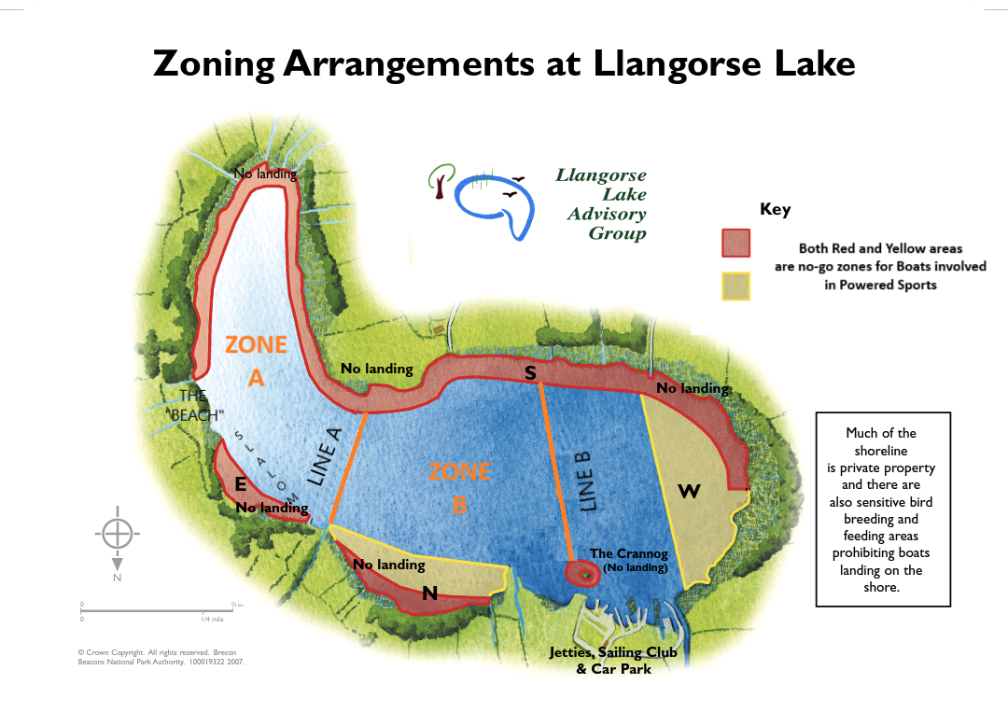

*Start and finish timings are affected by sunrise and sunset and should be adjusted accordingly, see rules.
** Zones only active if more than one type of activity taking place.

